**Task Screen shots**

**Step 1 – Creating two Resource groups in Southeast Asia & EastUS**

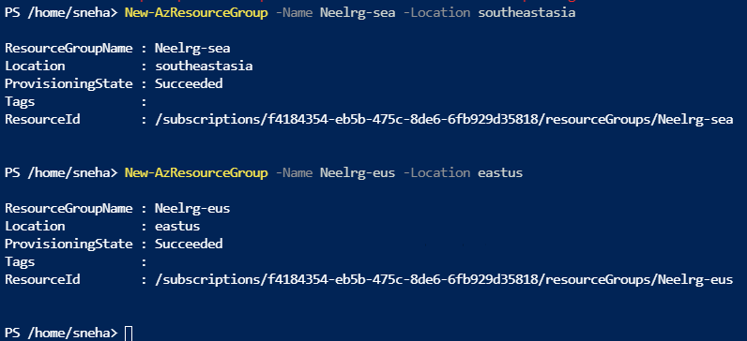

**Step 2 – Create Virtual Network**

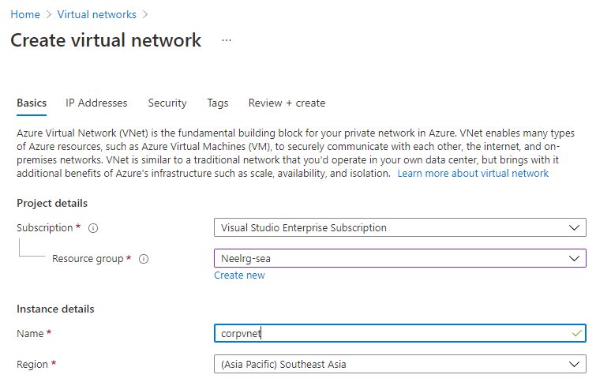

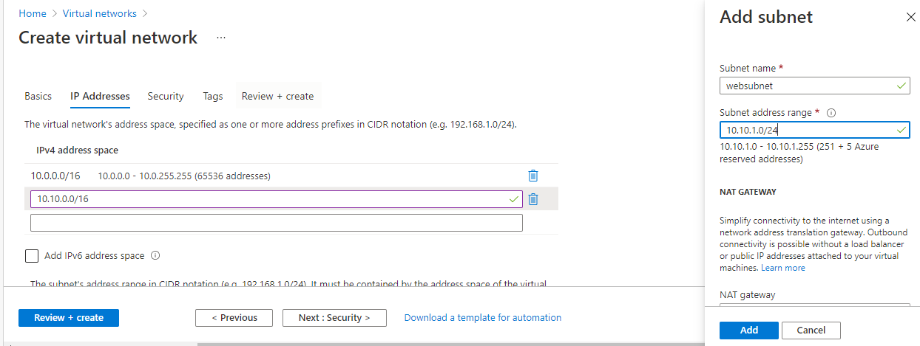

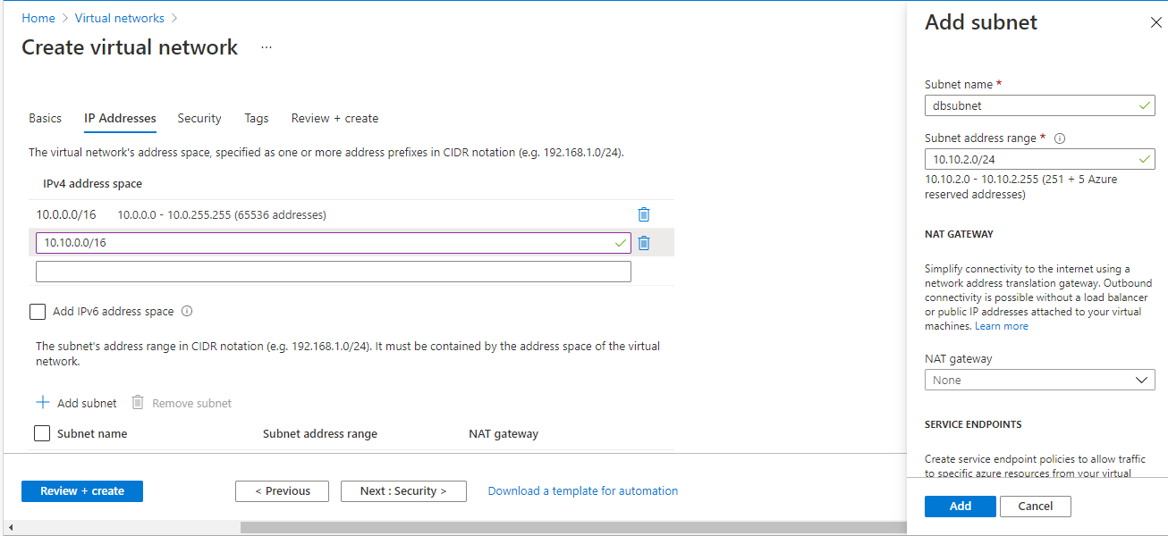

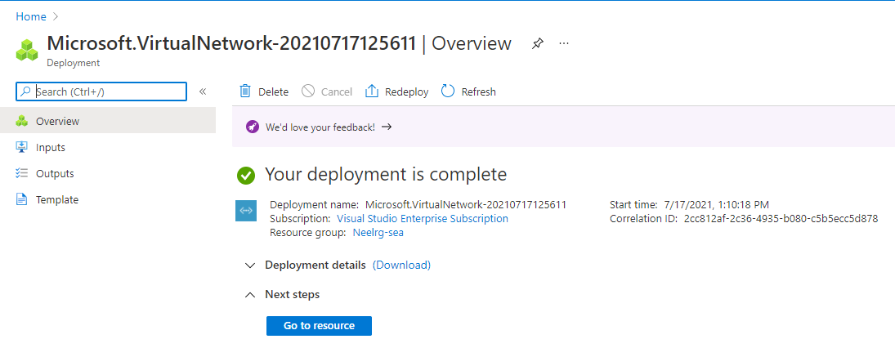

**Step 3 – Created NSG in Southeast Asia**

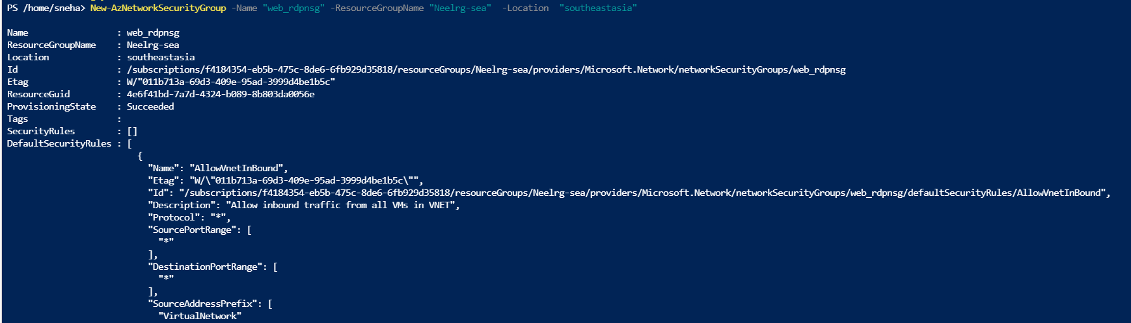

**Step 4 - Adding Inbound rules**

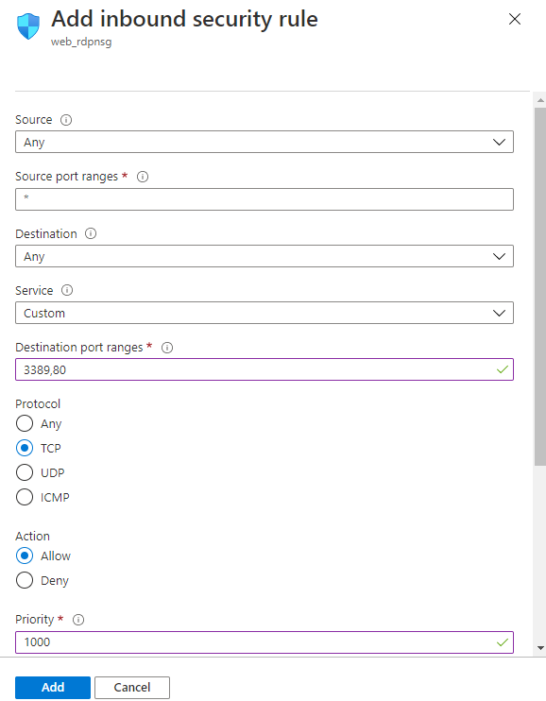

**Step 5 – Create one more NSG for another webserver -dbnsg**

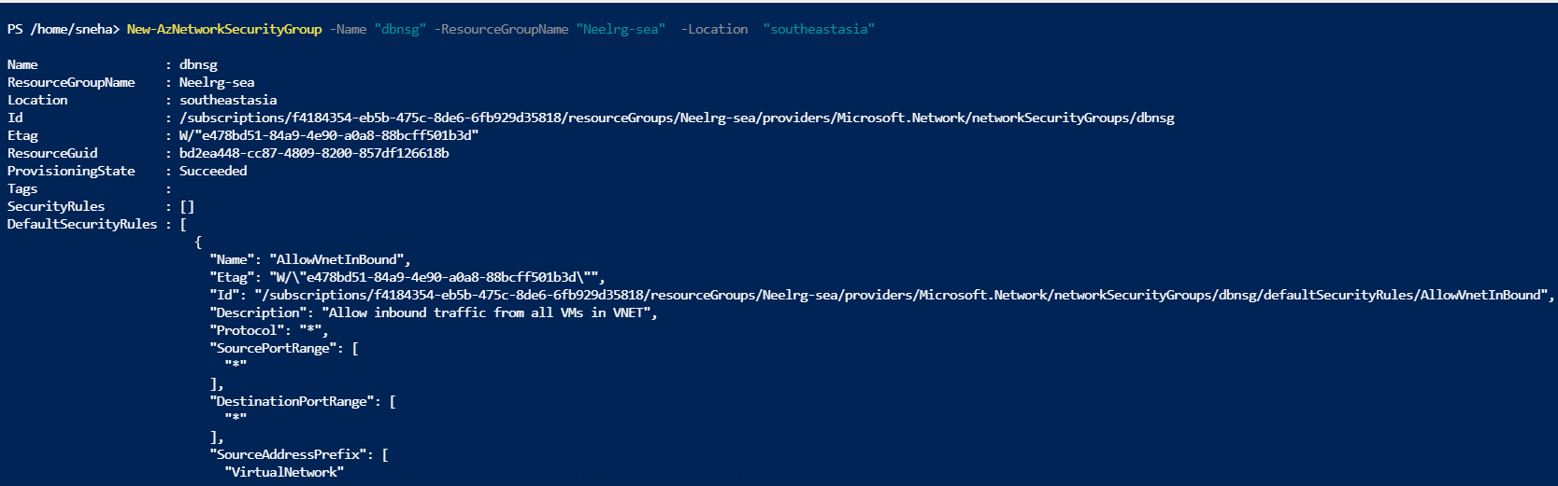

**Step 6 – Add inbound rules for dbnsg**

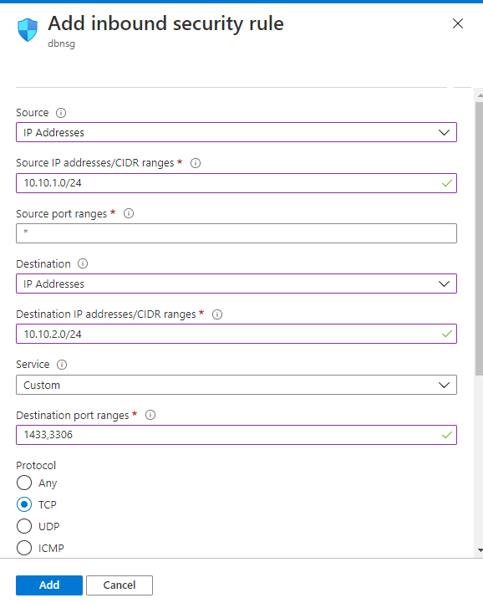

**Step 7 – Create Public ip address**

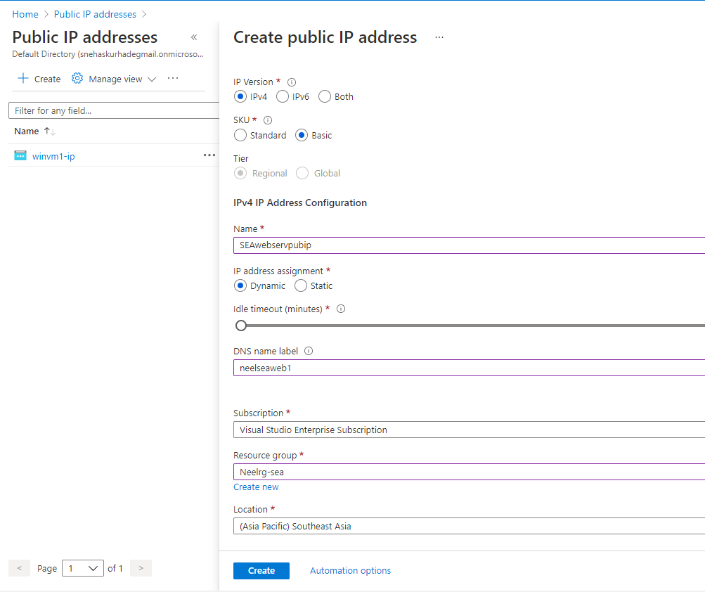

**Step 8 – Creating two Virtual Machine for webserver & dbserver**

1. **Webserver**

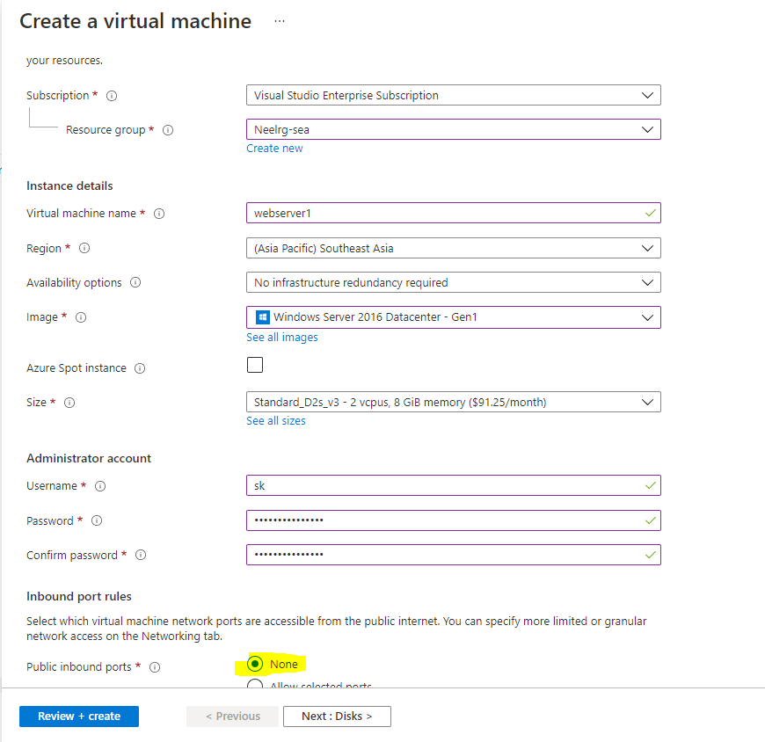

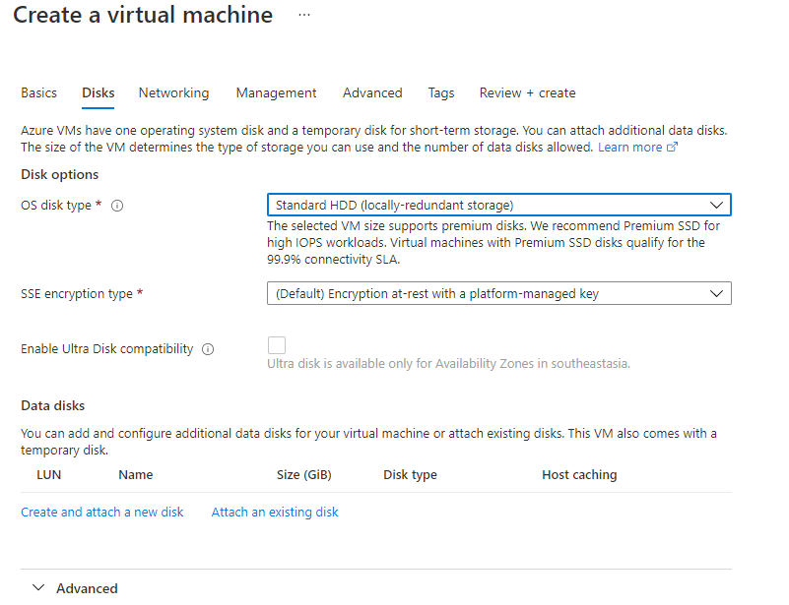

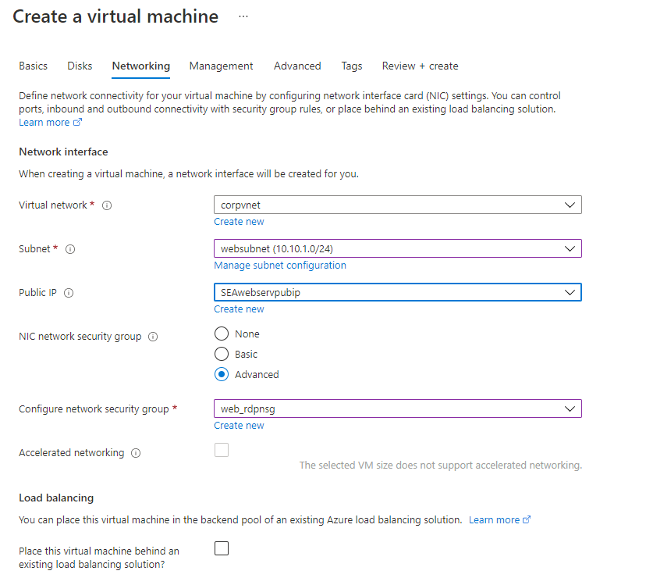

1. **Dbwebserver**

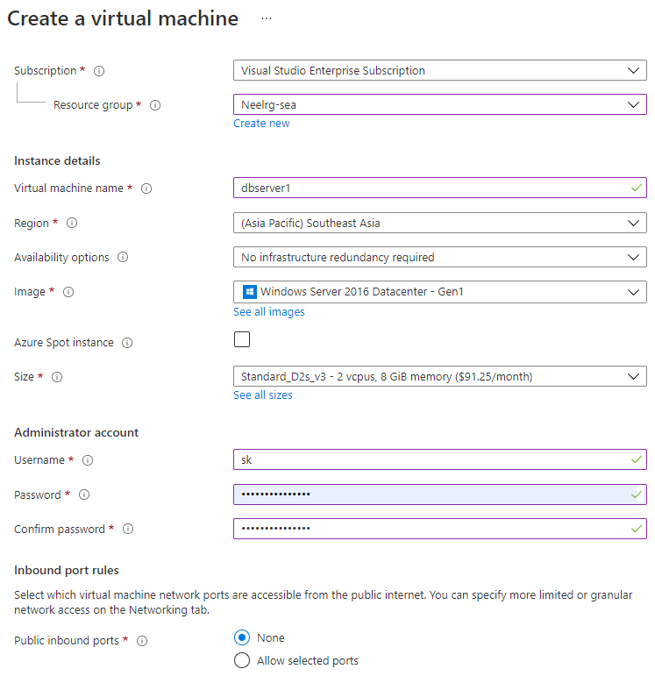

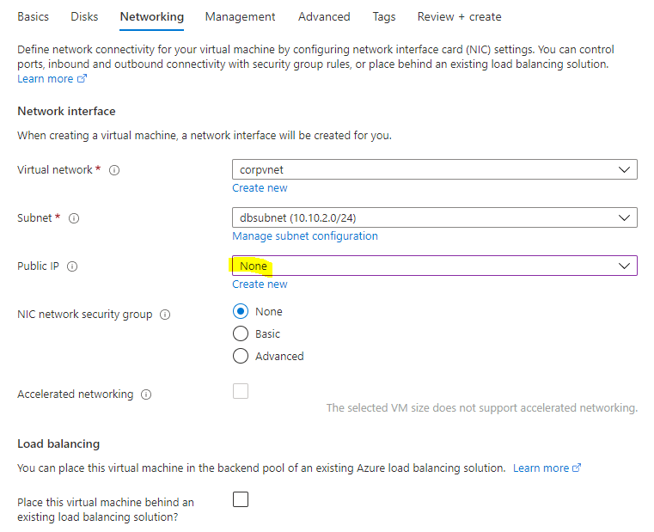

**Step 9 – Creating Availability sets (Scale sets) & Load Balancer**

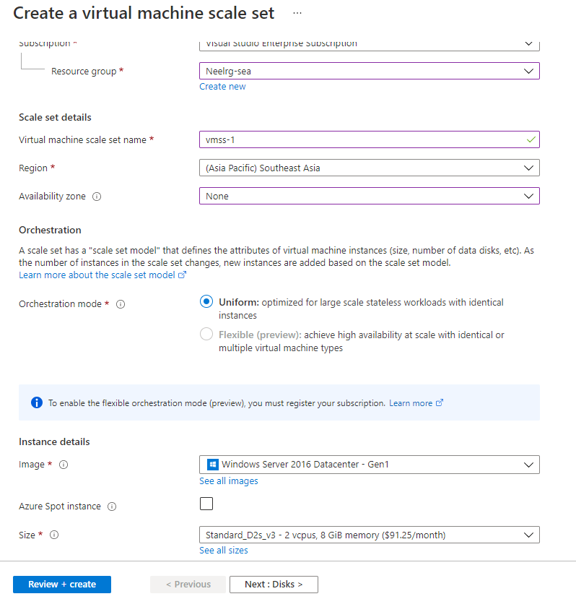

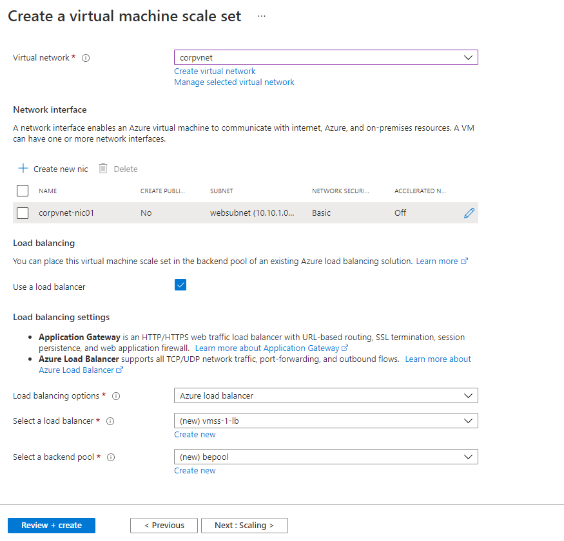

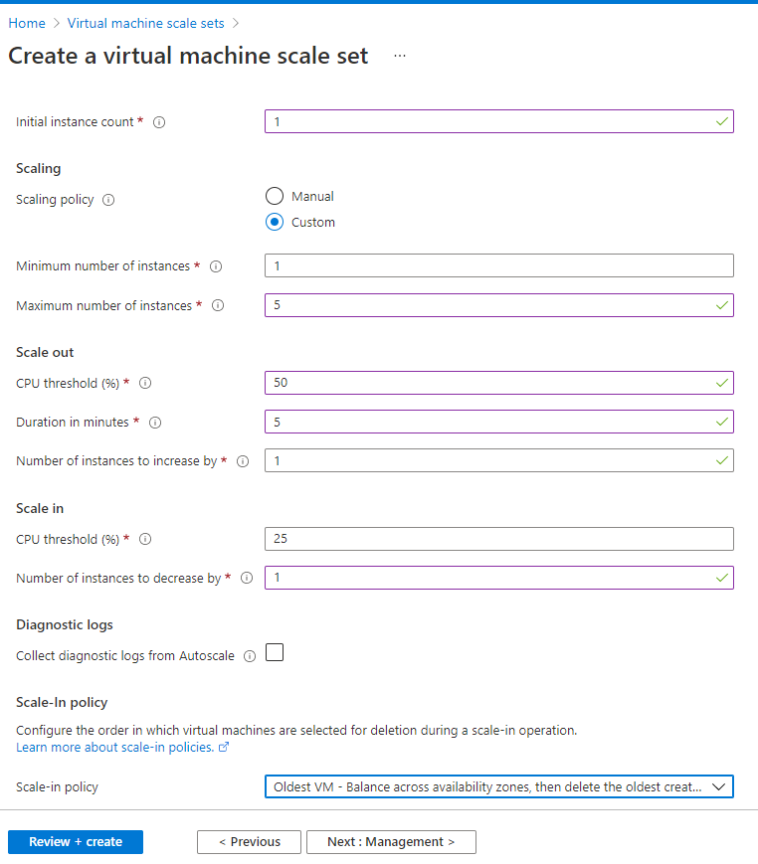

Adding Inbound rules for connecting VM

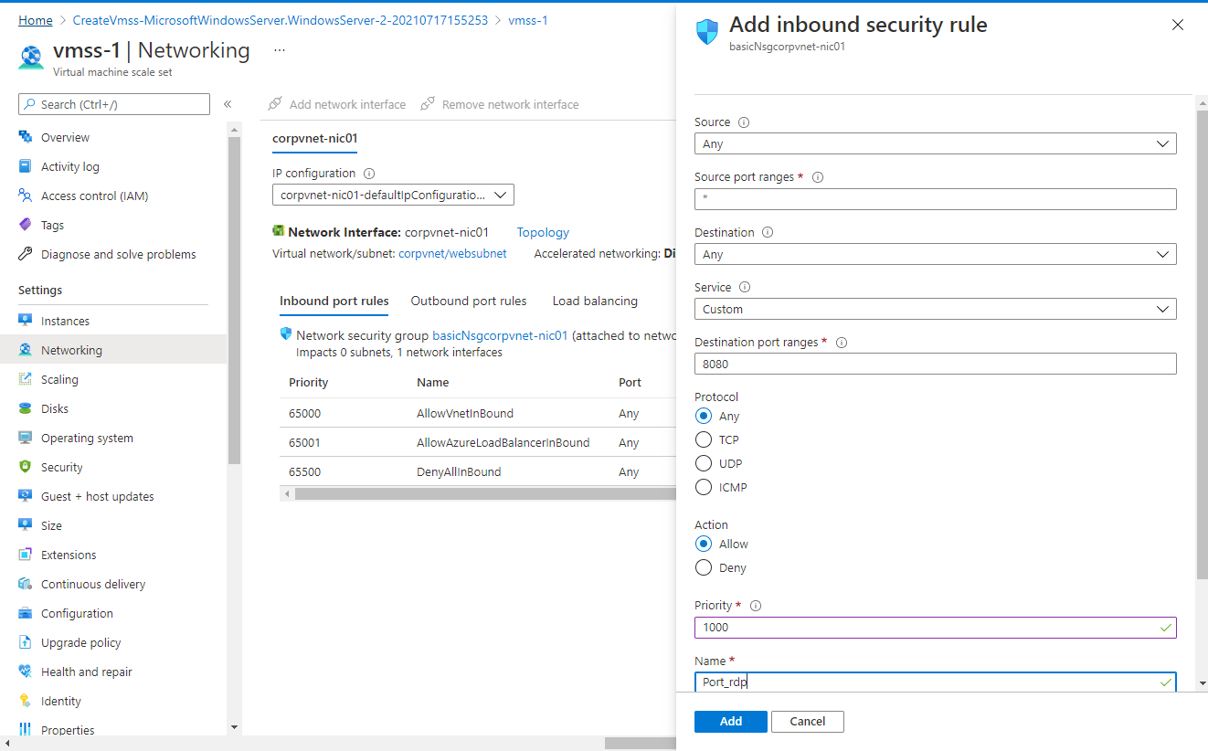

**Step 10 – Enabling Backup for above webservers (webserver1 & dbwebserver)**

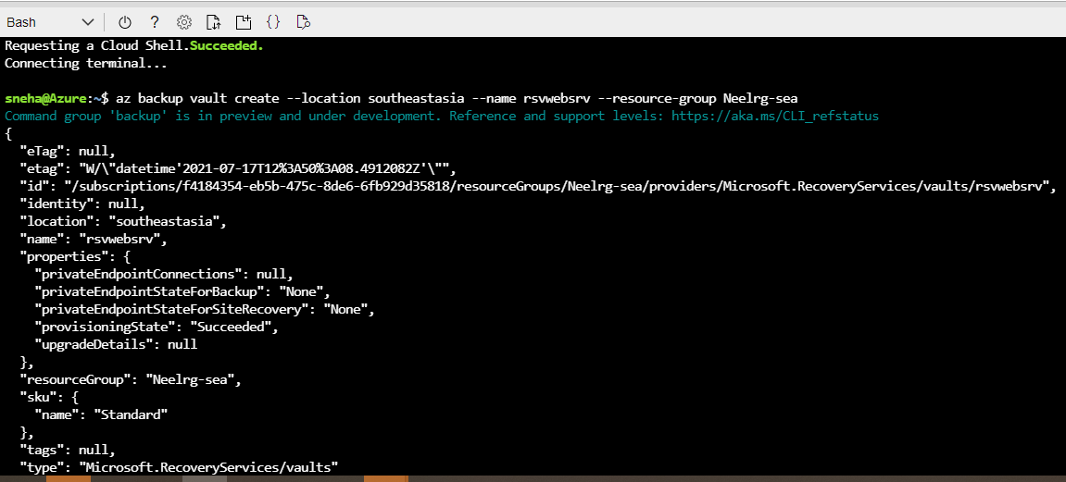

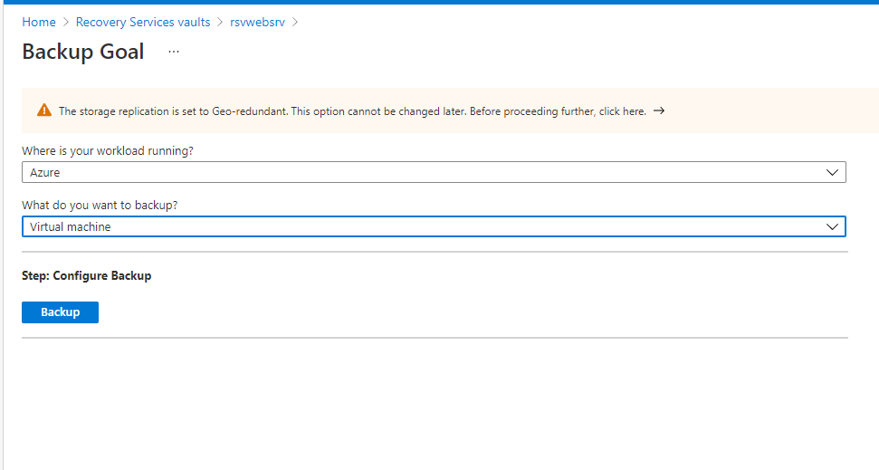

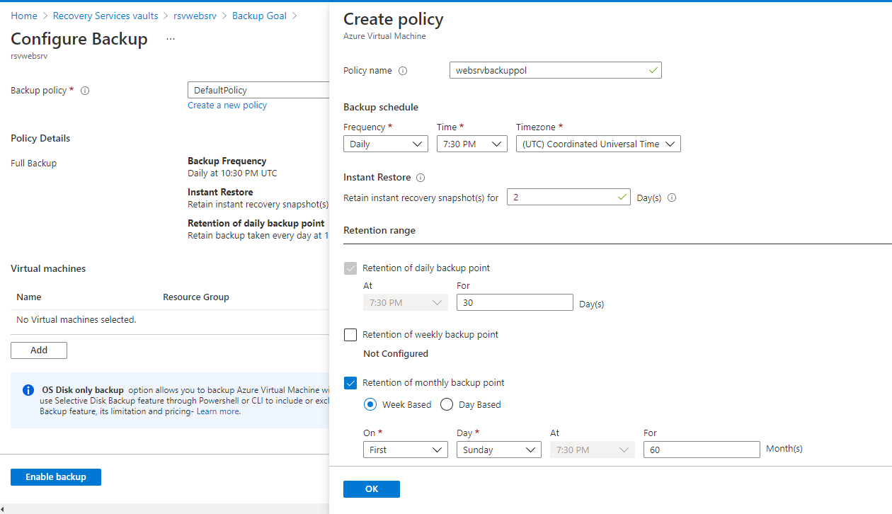

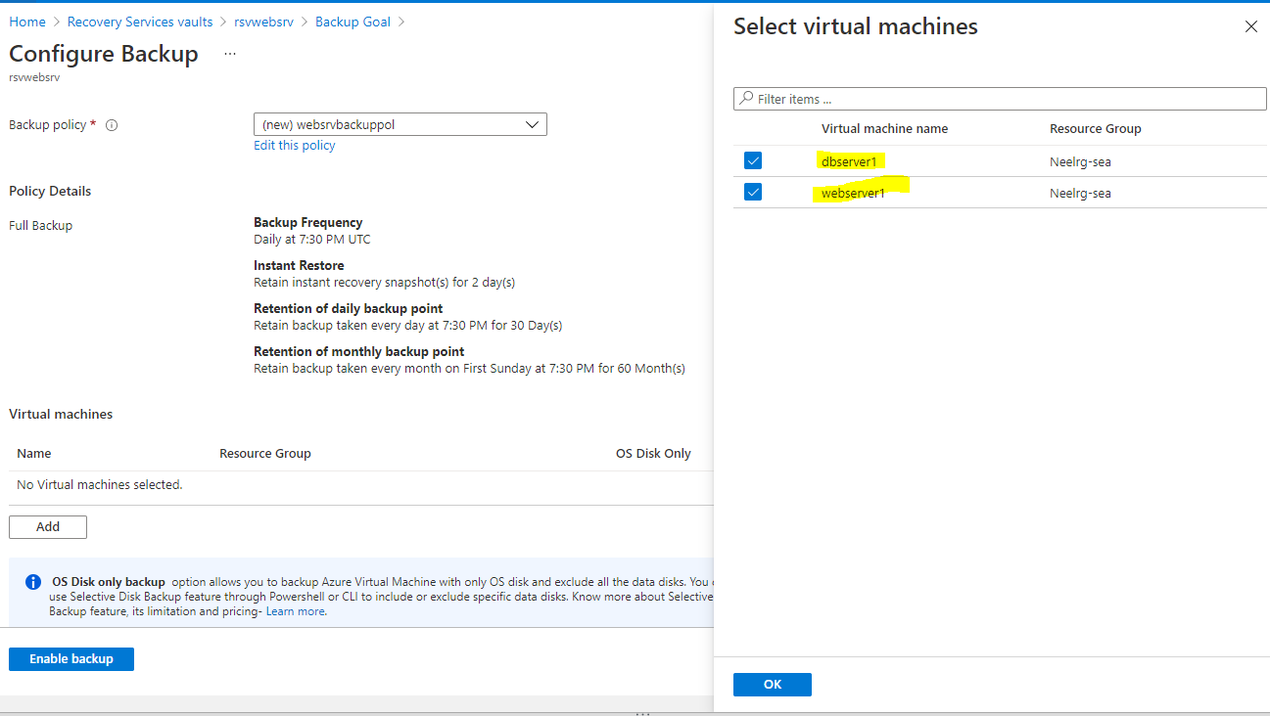

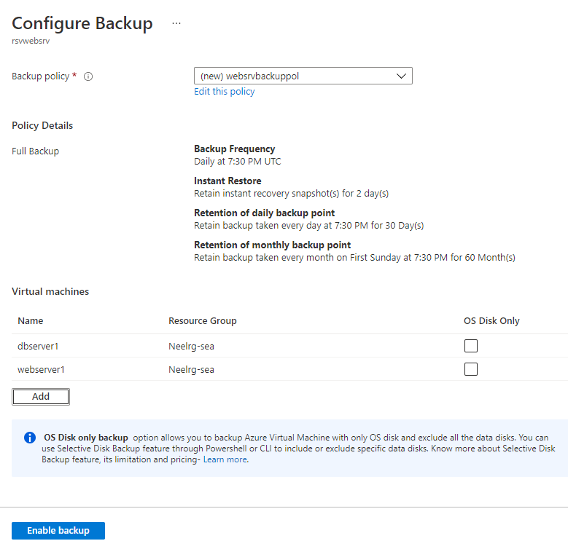

**Step 11 - Creating alert on webserver1 when CPU utilizes 80% above usage as below –**

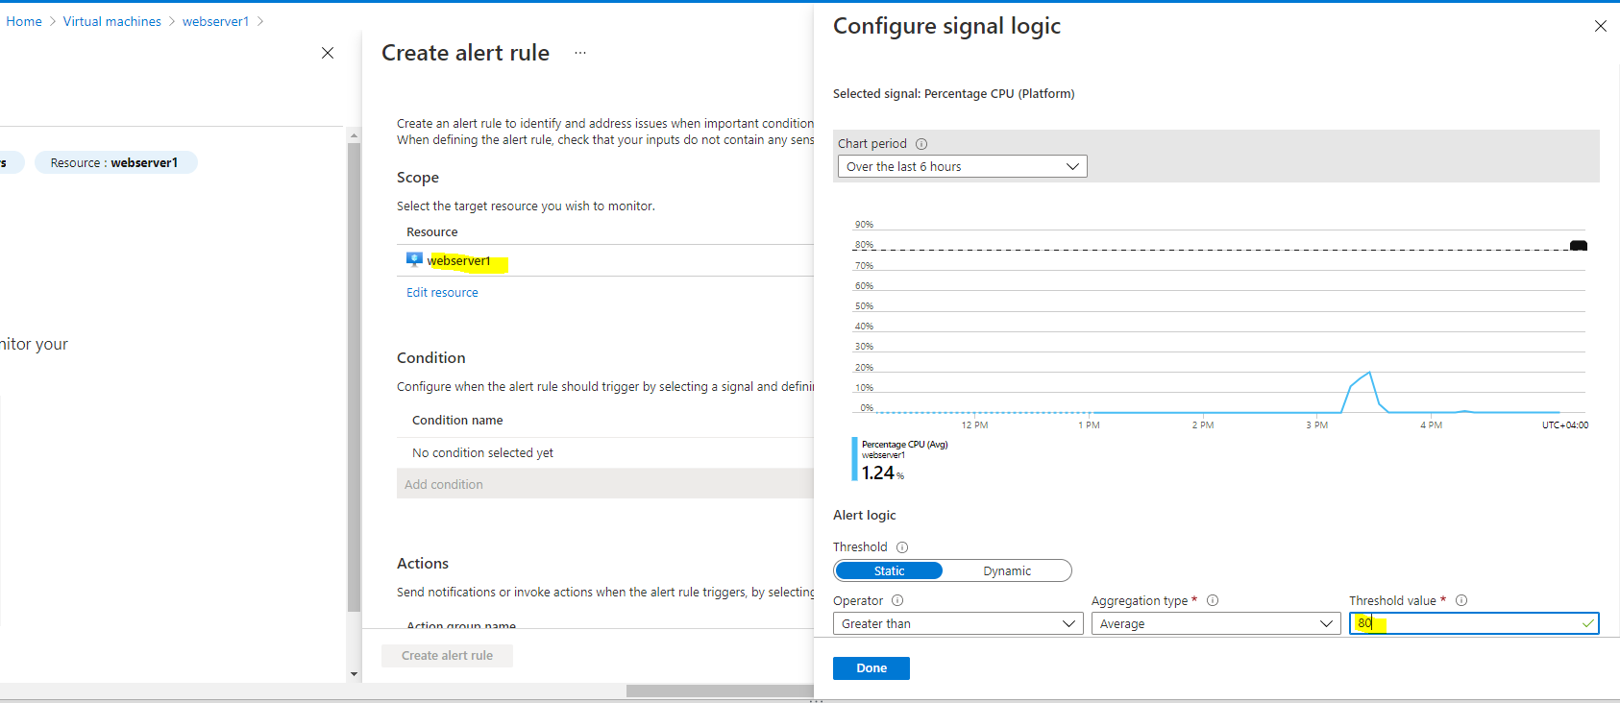

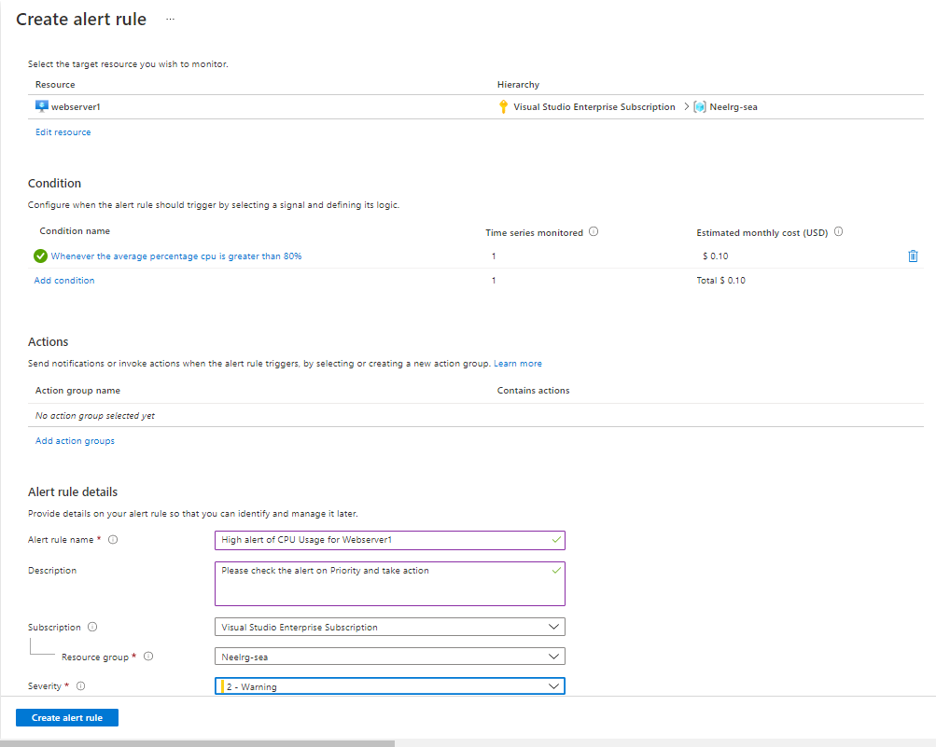

**Step 12 – Creating VM (server 11) in EAST US with Public**

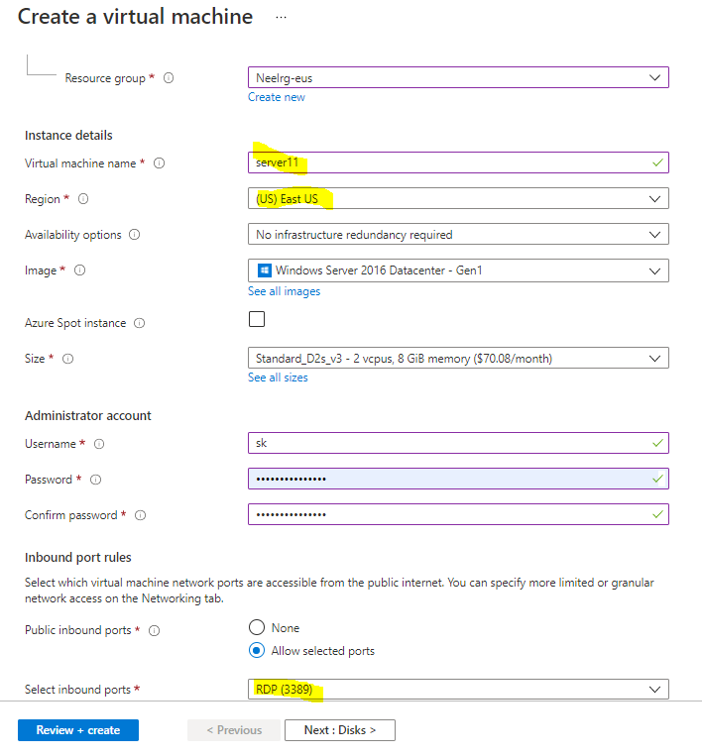

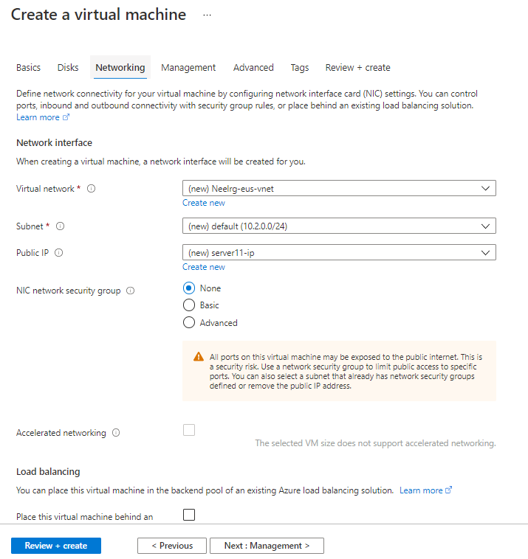

**Step 13 – Establishing secure connection with EUS & SEA sites through Azure Virtual network gateway**

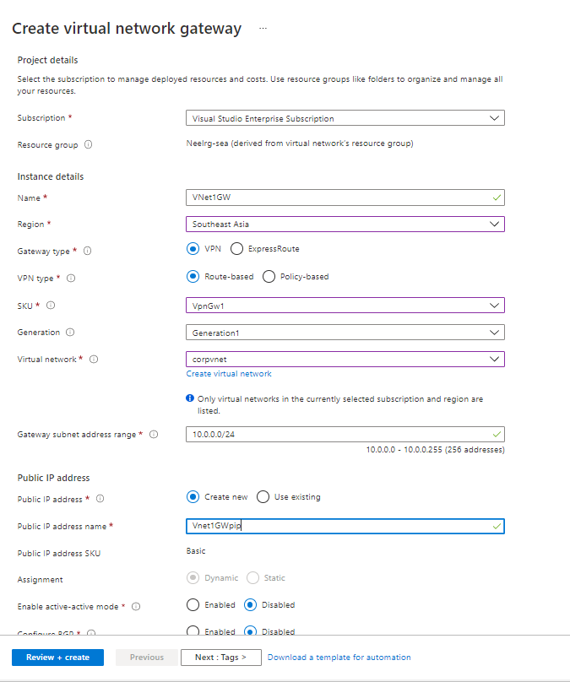

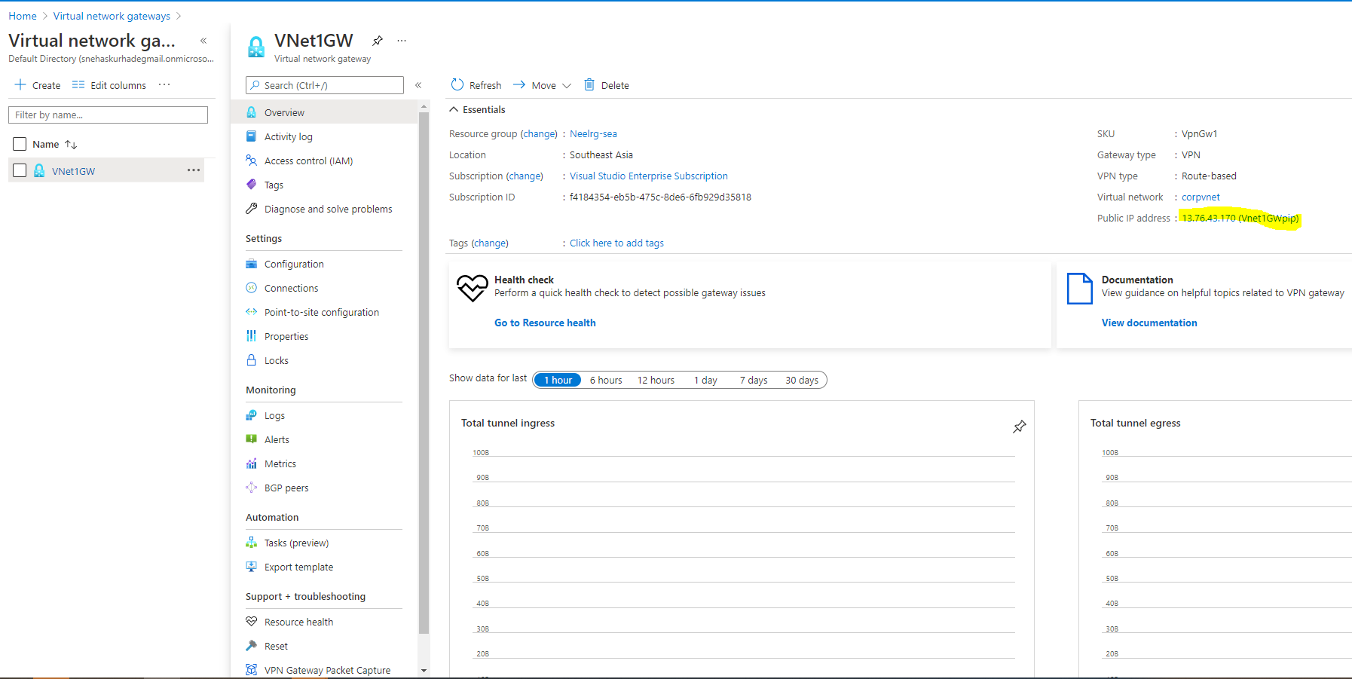

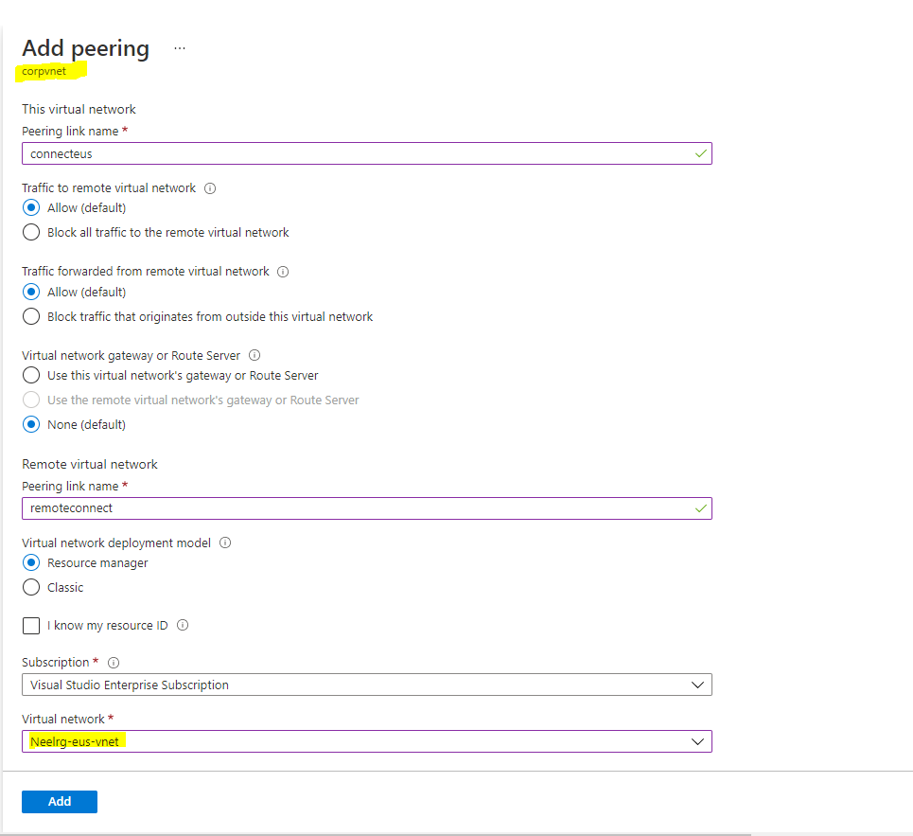

**Connected to dbserver which is without public ip**

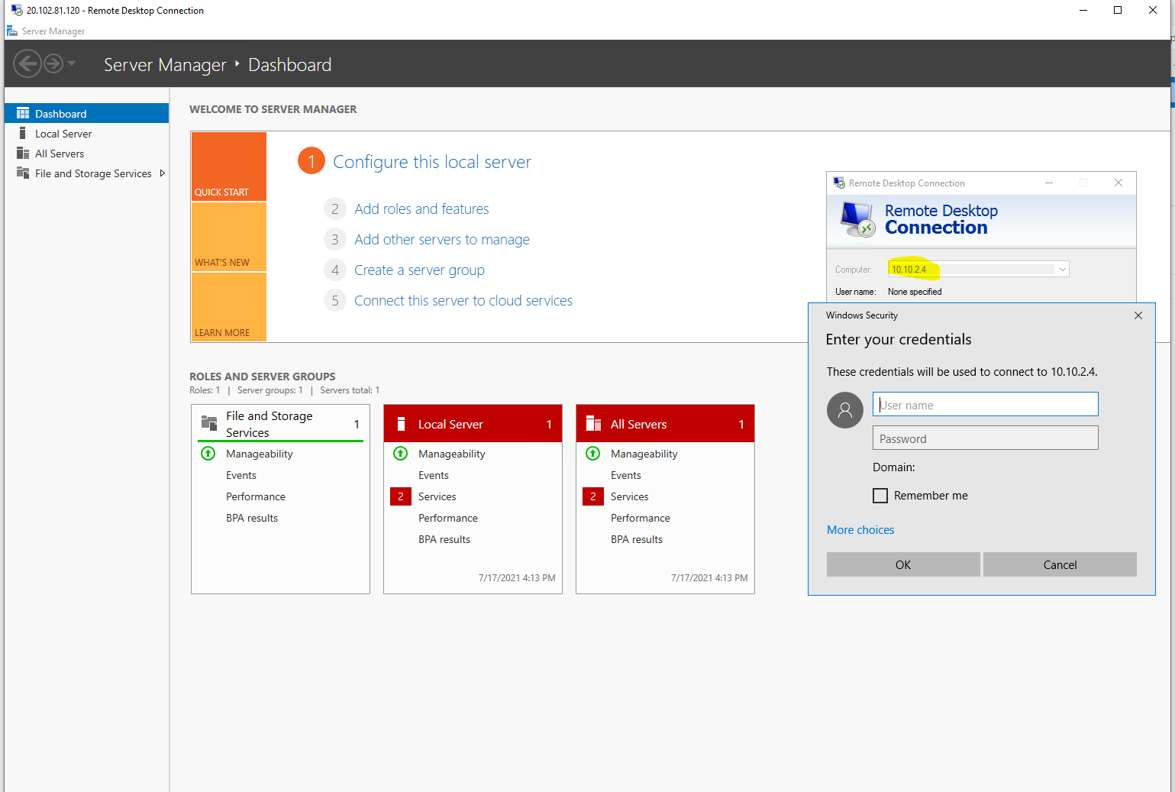

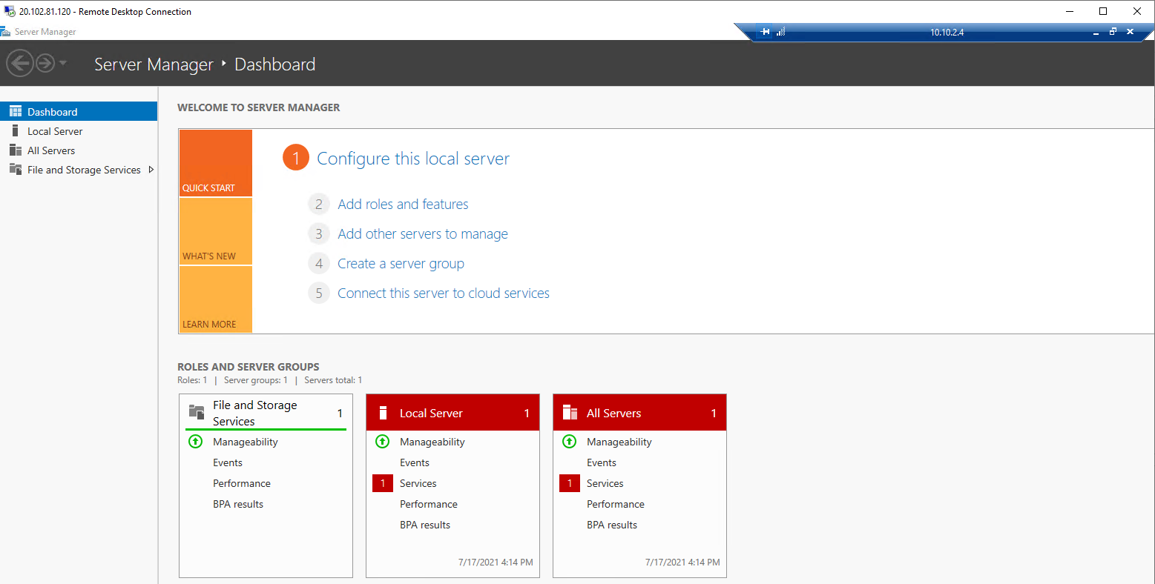

**Network Diagram –**

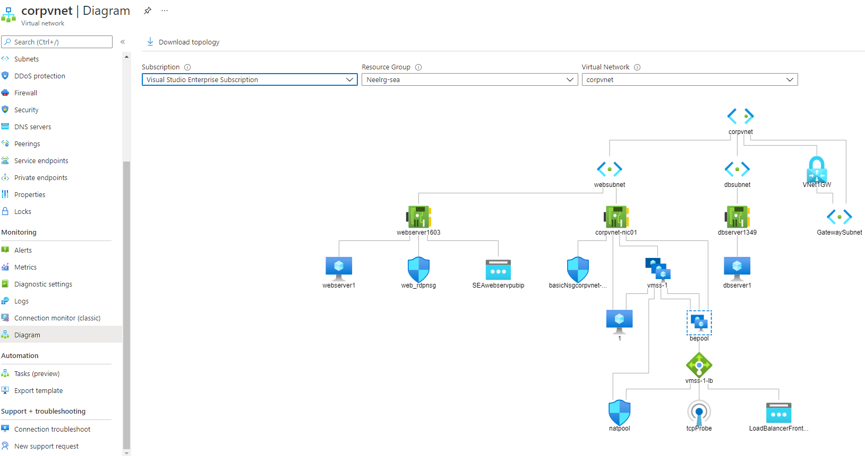

**Step 14 – Creating Storage account in East US with high availability in data center failure (ZRS)**

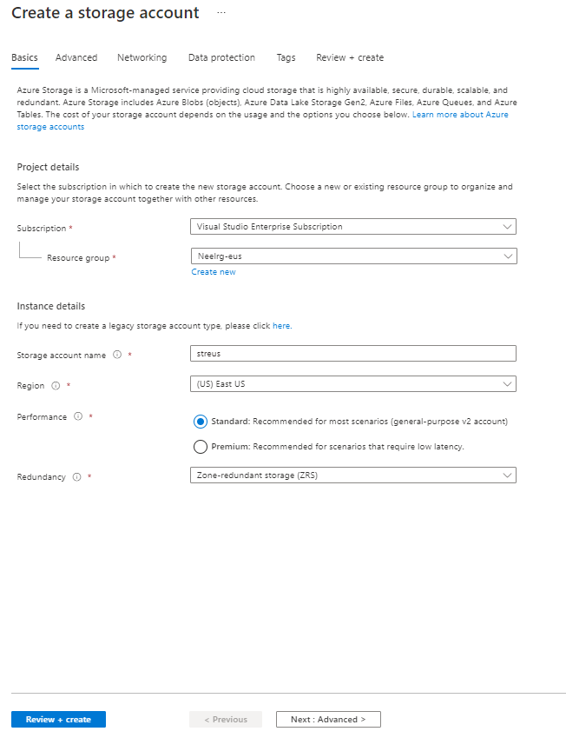

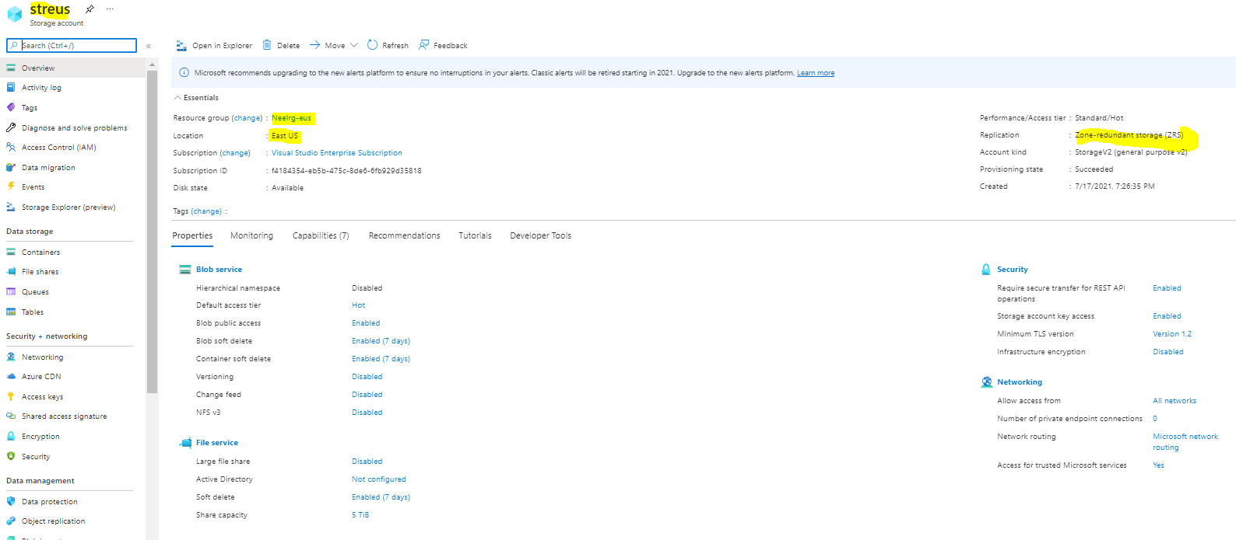

**Step 15 – Creating Storage account in SEA with high availability for data center failure (GRS)**

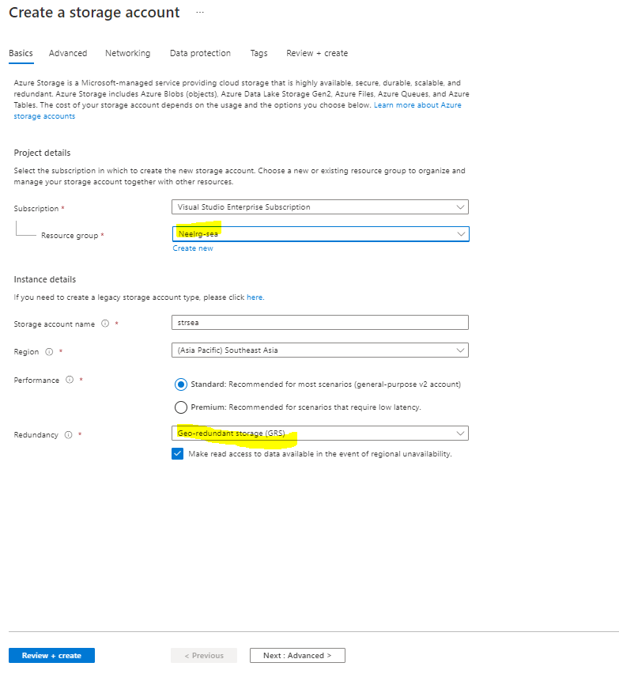

**Step 16 – Creating container in storage account**

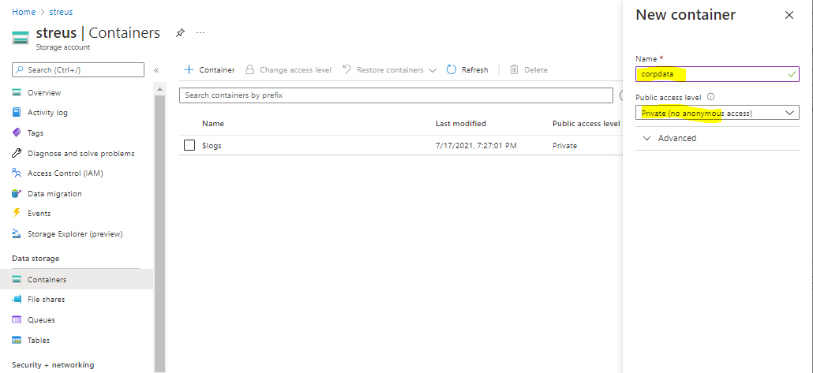

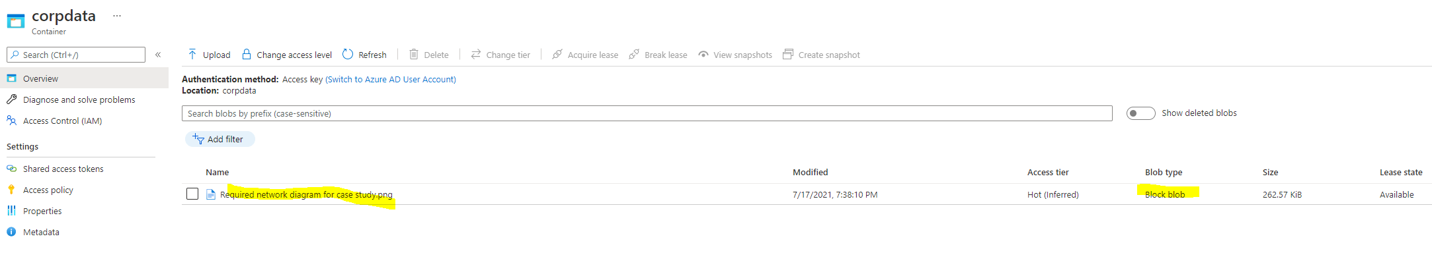

**Step 17 -Generating SAS URL & Keys**

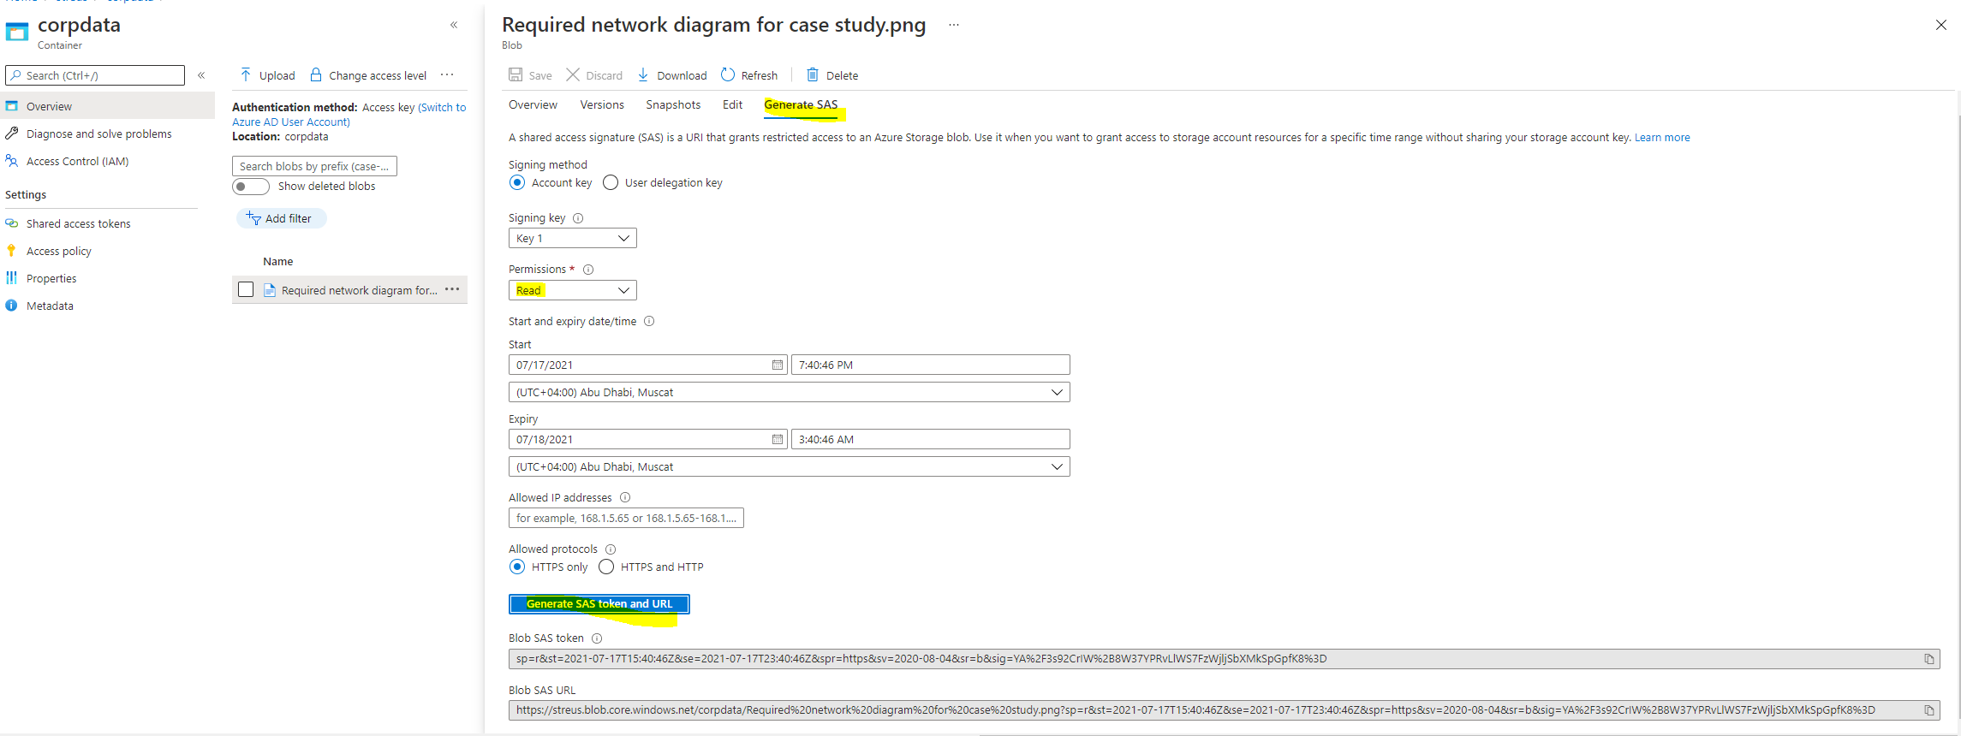

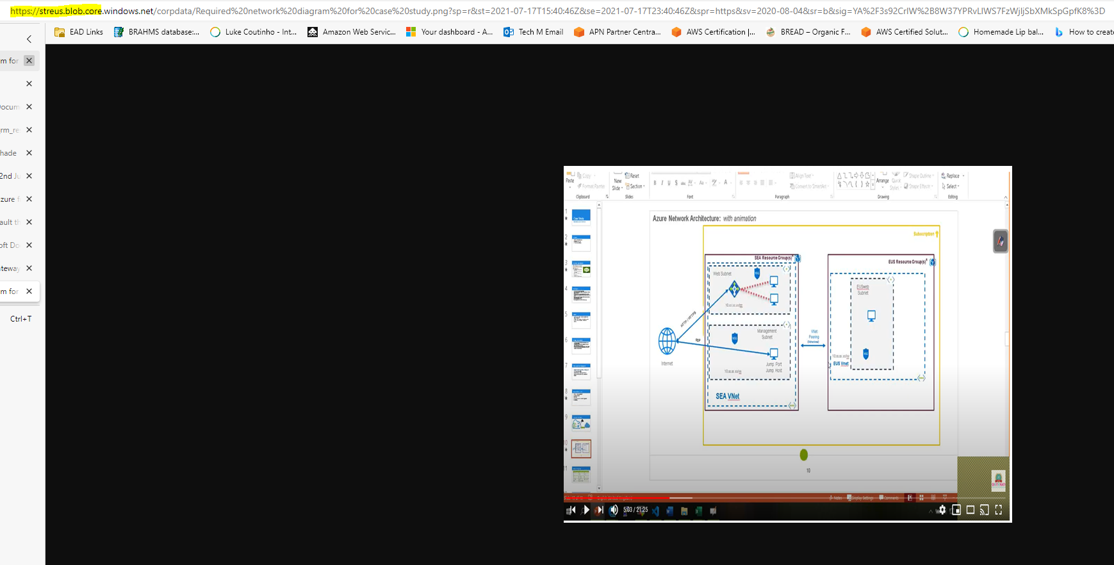

**Step 18 – Sales Manager accessing his resource from Windows Explorer**

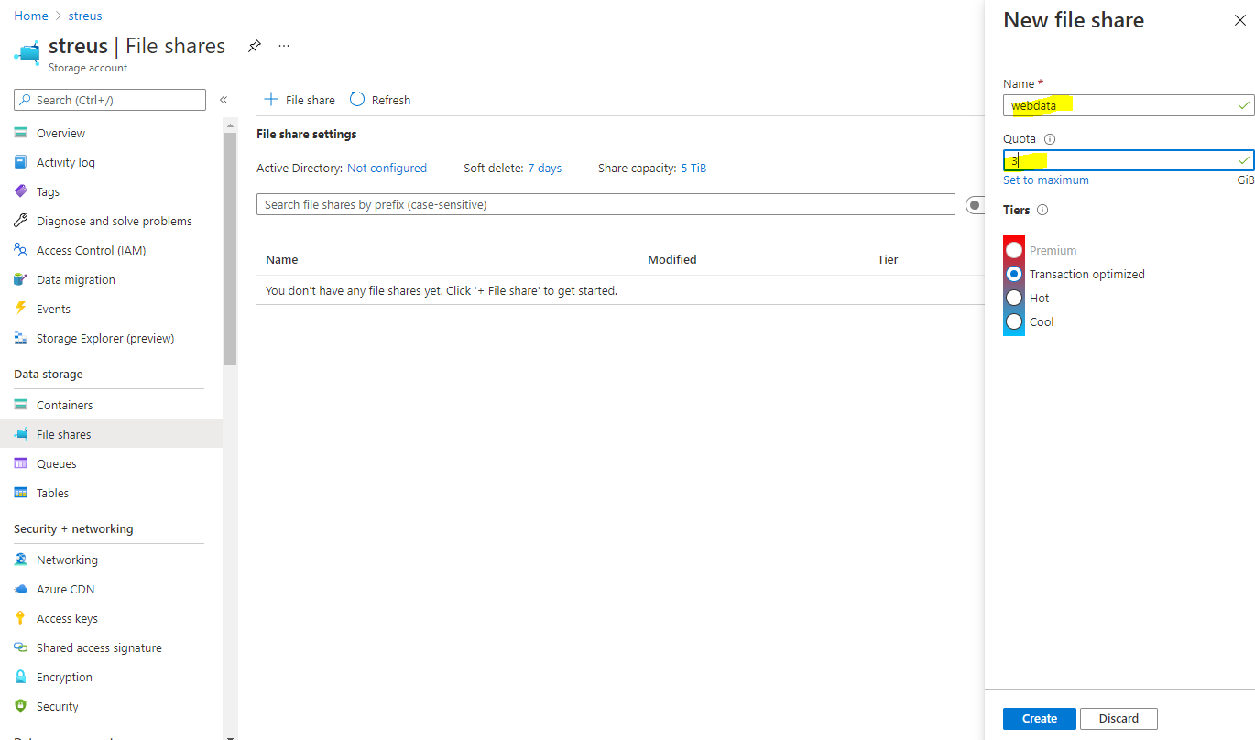

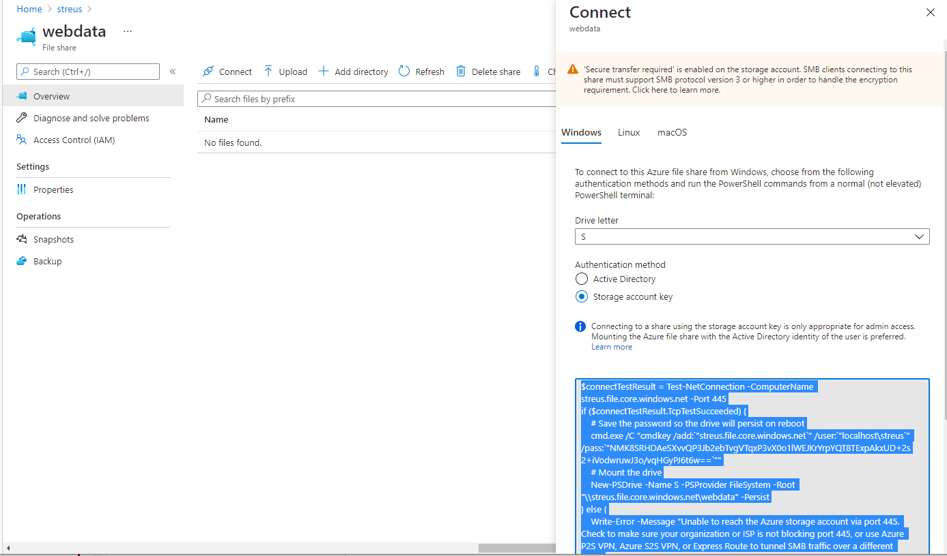

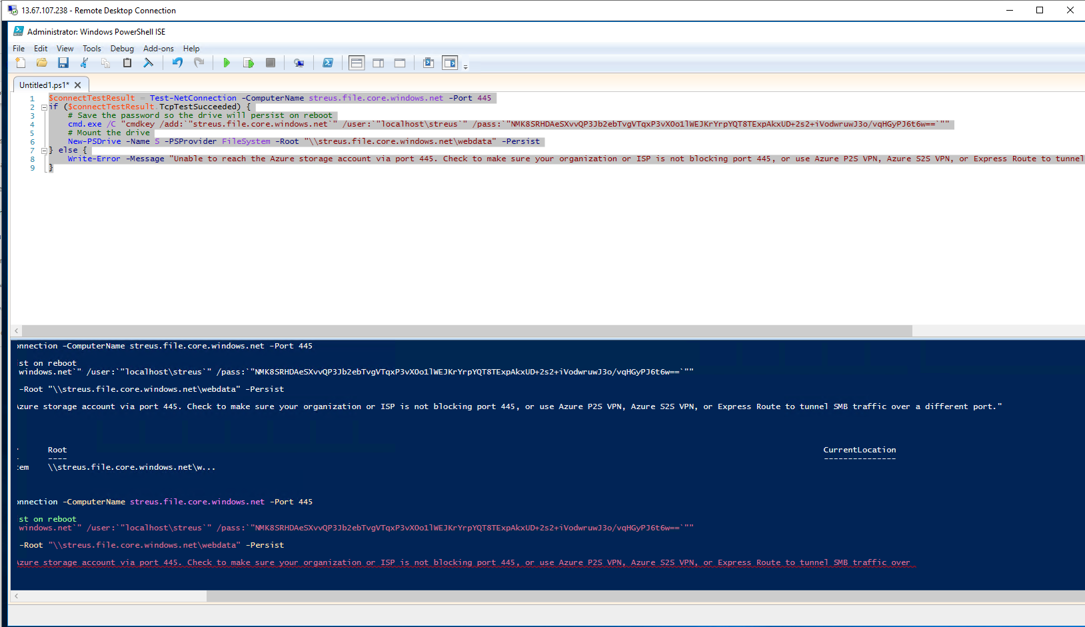

**Drive Mapped to windows explorer –**

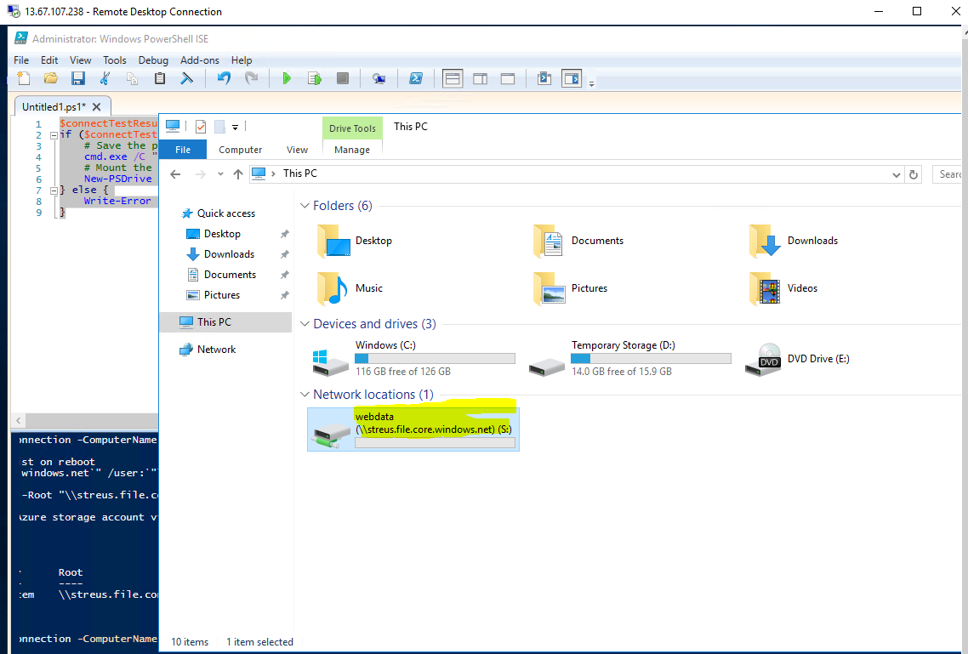

******************************End of Page*********************************************